“Newsy” the ESOL Tutor Newsletter
May, 2023
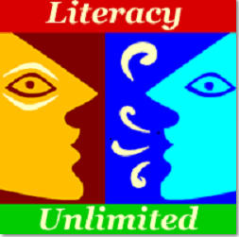

Welcome to “NEWSY” the Literacy Unlimited Tutor Bulletin

This Photo by Unknown Author is licensed under CC BY-SA-NC
Hi Everyone,
Spring has sprung! Yippee and there is lots going on at Literacy as we wind our way to the end of our fiscal year on June 30th.
General Information
May Baskets
They’re here! There are 18 May Baskets to choose from and they are in the lobbies at the Framingham Library and Christa McAuliffe Branch Library. The raffle is in full swing and runs through May 31st - the drawing will be held on June 5th. Tickets are $5 each or 5 for $20. All proceeds benefit Literacy Unlimited’s operational budget. You can buy raffle tickets at the Framingham Main and McAuliffe libraries’ circulation desks. Don’t forget to buy tickets for your family and friends. You can check the baskets out by visiting the website or click on May Baskets 2023
We would like to thank the following advisory board members and tutors for their help in pulling this event together:
Kathy Roth
Maria Barry

Bonnie Mitchell
Milena Rivas
Rebecca Bernzweig
Judy Mills
Tina Fan-Seto
Volunteer Appreciation Night Thursday, May 18 6 - 8:00 PM
If you have already signed up to attend this is a reminder about the Volunteer Appreciation Night.
Some of you have asked us about the “Cha Cha Slide” steps. We found a video that can be helpful. This is going to be a fun night so don’t worry if you don’t know the steps!
How to do the Cha Cha Slide Dance - YouTube
We are a proud grantee of the Massachusetts Service Alliance (MSA). The Volunteer Appreciation Night is possible because of funding from MSA.
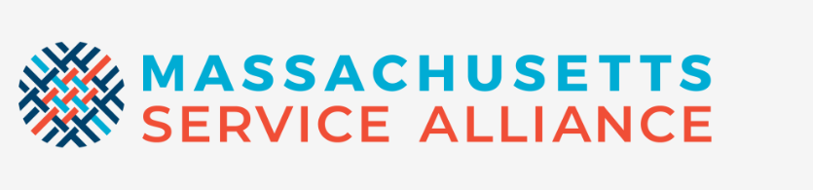
Literacy Unlimited - Clerical Assistant
We are actively looking for a part-time (15 hours per week) clerical assistant. If you know of someone, including a student who might be interested, let us know fplmail4@minlib.net
Literacy Unlimited and Library Closings in May
The Literacy Unlimited Office will be closed on Friday, May 5 because the staff will be attending a professional development conference. The library and Literacy meeting spaces will be open.
All libraries (Framingham and Natick) will be closed on Saturday May 27 through Monday May 29 for Memorial Day.
Good to Know – For Tutors
Tutor Professional Development/Workshop – Wednesday, May 31 6:30 - 8:00 PM on Zoom
Keith Folse is Baaaak! This time he will discuss some specific strategies for teaching grammar to adult learners starting with an overview of four possible scenarios:
- a 100% grammar lesson
- a task-based lesson that includes grammar
- a conversation class that includes grammar
- an English class with no overt focus on grammar
This workshop is possible because of funding from MSA to host professional development workshops in April and May.

Student Assessments in May and June - REMINDER

You should have gotten an email with a link to schedule your student’s assessment during one of your tutoring sessions in May. Thank-you to all tutors who have already responded. For most of our students the assessment is oral and adaptive (i.e., the questions get harder until the student can no longer answer them). Advanced ESOL students who successfully complete the oral test go on to a reading comprehension test. The results do not impact either your or your student’s participation in the program and so please help us to make this activity as low-key as possible.

If you have not responded yet, it is really important that you take the time to schedule this with us. This is an LVM (Literacy Volunteers of Massachusetts) requirement and is essential for part of our annual funding. We can join you at your tutoring session either in-person or online to administer the assessment. Click Here to Schedule an Assessment

English Conversation Class Leader Try-Outs

It’s not what you think it is. We have started many new in-person, drop in conversation classes and they are very popular with learners. The leaders have been working hard to start-up these classes and over the summer we want our class leaders to take some time off. When they do, instead of canceling their classes, we would like to give tutors who have thought about leading a conversation class a chance to try it out. If you think you might be interested or if you have been a substitute class leader in the past, please let us know. fplmail4@minlib.net

Basic Literacy (BL) Tutor Training Starting May 11

There is an upcoming online basic literacy tutor training that will start on May 11th and run on a Thursday evening schedule from 6 to 9 pm until June 15th. If you are interested please contact us and we can provide more information. fplmail4@minlib.net

Good to Know – To Share with Students
May Baskets – An Opportunity to Teach Students about Raffles

Tutors and class leaders, the May baskets are up in the Framingham and McAuliffe libraries. They can provide an ideal opportunity to teach learners about raffles and give them the chance to participate and support the literacy program that provides them with tutors and/or classes.

Latin American Celebration – A Choral Concert presented by Assabet Valley Mastersingers
On Saturday, May 13 at 7:30 PM at the Whitcomb Middle School in Marlborough there will be a choral tribute to the music of our Latin American neighbors. You can find out more about this event and how to purchase tickets at www.avmsingers.org If you or your student plan on attending we have 3 free tickets that we can share with you fplmail4@minlib.net
Tutor and Student Pair Accomplishments – You Rock!!!!
We are so very proud to announce that Kodjo (his tutor is Lauren) has been awarded the 2023 Ruth Derfler Memorial Scholarship of $1,000 provided by Massachusetts Coalition for Adult Education (MCAE). Kodjo will also receive a citation from the Massachusetts Senate President in recognition of his accomplishments. His name may sound familiar to you as Kodjo and Lauren have been highlighted in a previous Newsy.
This is a reminder to please let us know of your student’s accomplishments large and small as we love to share them with the community. And we are on the lookout for scholarship and grant opportunities for ESOL students particularly for students who are entering post-secondary education like community college, 2 year degree/certificate programs, or 4 year programs. If your student is eligible for one of these scholarships we can help with the application.

Last Word
Whew, another long Newsy. It is a lot to read but then again there is a lot going on and that’s a good thing. Thanks for reading to the end,
Karen, Michelle, Laurie, and Marjie

