Virtually Browsing Fiction Using NoveList

- Search for a title you like in the Minuteman Catalog, in this example, The Woman in the Window, by A.J. Finn:

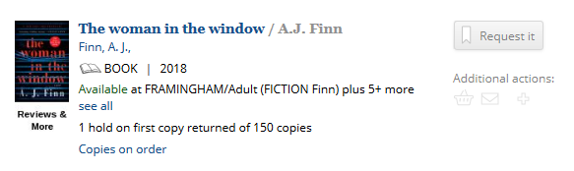

- Scroll down to see the NoveList Results section.
There are two sections that will take you to authors and titles that are similar to this book:

Read-alikes: Grouped into similar titles or similar authors
Story Elements: Aspects of the story that appeal to the reader, genre, characters

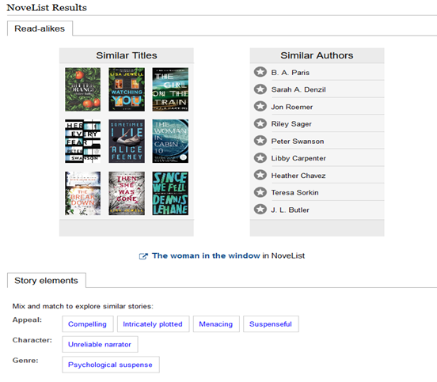

Similar Titles

Click on a book cover, in this example, Watching You:
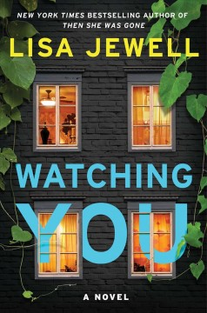
Watching you
Lisa Jewell
Why this title?
These intricately plotted, suspenseful and compelling murder mysteries involve long-held secrets and voyeurs who notice suspicious activity in their upscale neighborhoods. Woman in the Window takes place in New York City while Watching You takes place in a British suburb. -- Alicia Cavitt
Find it

NoveList provides an explanation of why it recommends this title in relation to The Woman in the Window, and gives a “Find It” link to that title in the catalog. The description here uses key story elements like suspense, voyeurs, and murder mystery.

Similar Authors

Click on an author’s name, in this example, Peter Swanson:
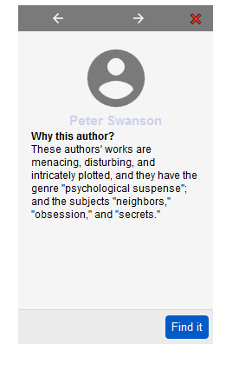

NovelList provides an explanation of how this author’s work relates to that of the author of The Woman in the Window, A.J. Finn, and the elements that may interest you.

Story Elements

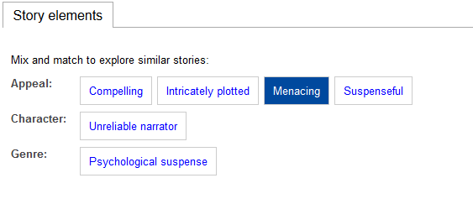

- Hover over the story element and a description will pop up
- Click on that story element -- in this example, “Menacing” -- and Novelist will provide suggestions of books that share that trait:

